TEARS Leadership Team
October 2014

Rod and Twila Davis
Executive Director, TEARS Ministries (1995 - present)

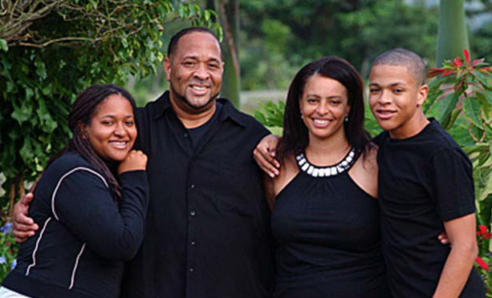
Shekinah, Rod, Twila & Isaac

The Davis family founded TEARS in 1995. I am currently serving as the Executive Director. Prior to my move to the ghettos of the Dominican Republic, I gained eight years of experience in inner-city ministries in the United States. My experience in program development, group facilitation, cultural studies and interaction, church planting, bible studies, and staff training has afforded me measurable successes during my tenure. I am also bilingual in Spanish and English, skilled in graphics, video programming, and video editing.

Since the ministry began in 1995, my leadership has included numerous projects including, but not limited to: a government-accredited school of over 400 children, a Haitian school with 80 children, two church plants, TEARS Pastor fellowship with 37 pastors, several social service outreaches—including a water purification center, clothing and housing for the needy, a missionary intern program, an agricultural project, hosting numerous short-term mission teams from the US and Canada, the purchase of 5.5 acres, and a building project that will provide short-term team dorms that sleeps 30, a leadership training center and a future vocational training school.

I am blessed to have Twila Davis as a partner of 24 years, a 20-year-old daughter Shekinah, and a 18-year- old son, Isaac. Each of the Davis family members have played a significant role in the success of the ministry.

(Rod Davis is acting as Partners in Deed’s agent in the Dominican Republic, in compliance with Canada Revenue Agency guidelines.)
Antonio del Rosario (Chelo) and Judith de del Rosario
Director of TEARS School

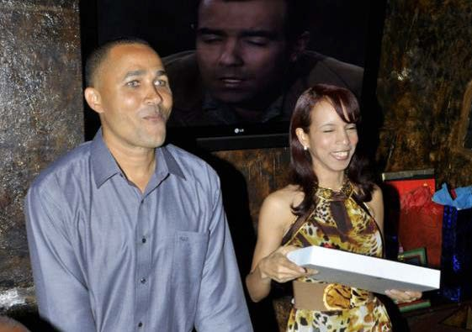
Chelo and I received Jesus at the age of 9 years old. We did not know each other and lived in different cities. He in Rio San Juan and I in Santo Domingo.

At the age of 12, we received the Lord's call to ministry through the preaching of a missionary. I was attending camp in La Vega and Chelo was participating in a missionary activity in Rio San Juan.
Neither knew that God was doing this work simultaneously.

After this, God was opening doors to participate in various ministries. At 16 years old, God allowed me to belong to
the Child Pro-evangelization Alliance (APEN). Chelo was an educator at a school and when I was 18 he also entered the APEN children's ministry, where we received training in psychology and ministered at various schools and churches. Coincidentally, we met again taking training together in Santo Domingo and in 1994 we got married and were ordained as Directors of APEN in La Vega.

Later, we went to work as youth pastors in the church The Good Samaritan and there we met Rod and his family. God prepared everything so that then we became part of the TEARS Ministry and, consequently, were part of the foundation of the TEARS Christian Education Center in 2000.

We were away from TEARS for 4 years doing personal projects. Chelo taught and led mission trips at the La Vega Christian School, and also served as assistant director at the Polytechnic San Ignacio de Loyola in La Vega. I also taught at the La Vega Christian School and wrote "Youth in Action,” a didactic book that has been used as a tool to evangelize many young people at different schools.

Later in the summer of 2011, Rod asked us to lead again at the TEARS Christian Education Center, where we work now to glorify the Lord.

We understand that the Ministry is our way of life and the call of God is irreversible. We encourage anyone who has received a call from God to walk in humility and develop His beautiful career of service, glorifying God in whatever He presents.

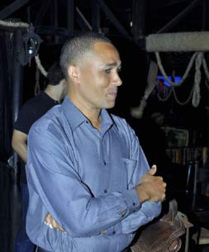

Obed Peñuela
Youth Pastor El Camino Church and Manager Agricultural Projects

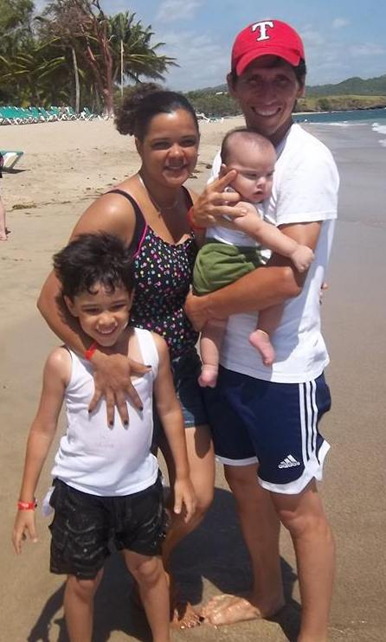
I am Obed Peñuela Carreño. I was born on January 18, 1980 in
Barrancabermeja, Colombia.

My parents, Tito Penuela H. and Martha A. Carreño, have been dedicated for 33 years to the pastoral life that influenced my Christian formation as well as that of my siblings Elvia, Javier and Martha
Liliana. This helped us to be involved in the service of the Lord from an early age.
God has given me the gift of learning to play music, guitar, piano, etc. During my childhood, my father, a pastor dedicated to the work of
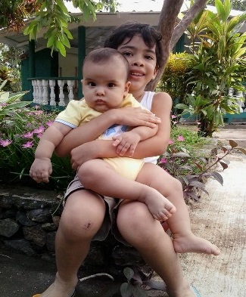
Evangelism, took me on long journeys through the mountains of Colombia to share the Gospel—an action that caused persecution by the Colombian military guerrillas. His hope was that, if during one of his journeys he encountered guerrillas and was threatened, his life would be spared because he was accompanied by a child.

I grew up in a home with great needs, due to terrorist threats, which forced our family to move from time to time to different parts of Colombia. That is why my elementary education was gained through different schools. My secondary studies were at the Technical Industrial Institute in Barrancabermeja. Due to lack of resources, I did not go to college.

During my adolescence and youth and while in high school, I was involved in the church, where my parents pastored, as a youth leader, worship team manager, Sunday school teacher and a Christian music performer through radio programs, etc.

Throughout life I have experienced God's many miracles such as being brought back to life after dying, at the age of two, from typhoid fever, having had my right index finger healed after the bone and tendons were out of place, overcoming hepatitis, and experiencing God’s continuous provision for the sustenance of my family, and so on.

Among these miracles is the way God brought me to the Dominican Republic not knowing anyone and having no money for papers and tickets. On September 22, 2004, I arrived in the Dominican Republic and have been working as a volunteer missionary linked to TEARS Ministries, serving as a musician and being part of the pastoral staff at El Camino Church.

I use soccer as a tool of evangelism to win children and young people who are drowning or falling into drugs and theft. I also manage the water purification plant for the community of María Auxiliadora in La Vega.

I met, fell in love and married Rosmary Rodríguez. We are blessed with two sons, Zion Obed and Ian Luca. To this day, I continue to work with the TEARS Ministry, always waiting for God’s perfect will in my life.

Hector Julio Cedeño and Odeinne (Diana) Jean Pierre
Pastor of Soto Church and Director Soto School

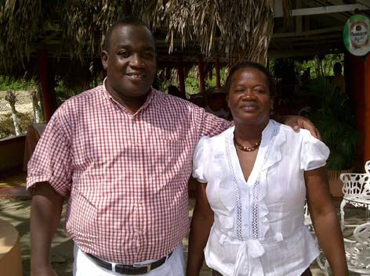
I am Hector Julio. I was born in Jacmel in 1969 and am married to Odeinne Jean Pierre (Diana).We have four children: Baez (b. 1993), Behn (b. 1995), Jeffry (b.
1997) and Yulissa (b. 2010).

After my studies, I worked as a supervisor in a supermarket in Port-au-Prince, Haiti. At one point, I was abducted by three men who tried to kill me and take my job. They placed me in a vehicle and drove me out of the capital into the province of Saint Marc, about 40 kilometres away, to kill me. But God saved me. One phrase I was able to repeat that day was, “Men, without the permission of God, you cannot pull out even one of my hairs.” (While he does not
elaborate, he obviously was saved from death by repeating this phrase and came out of this experience determined to serve God.)

In 1995, my family and I left Jacmel and Cap-Haitien and moved to the Dominican Republic in response to a special call from God with the objective of furthering God’s kingdom here. The goal was to touch the hearts of people in need, to live amongst them, and to reflect Jesus Christ through the love that he expressed to me through his sacrifice and service.

We lived in La Romana, a city situated in the east of the DR, and spent seven years there (1995 - 2002). We then left La Romana to live in a poor barrio situated near La Vega called El Tanque. It was really hard living there, as many people were delinquents and drug addicts. So we left and moved into another barrio called University Village. There we met a Dominican pastor who rented us their church which enabled us to continue our ministry. In 2005, while we were meeting in this church, we met an American missionary (Jim MacDonald) who helped us purchase land to put up a church, a home and dormitory. During that same time (2002), we met Rod Davis, founder and Director of TEARS, and since then we have been part of the TEARS ministry.

We can now say that we are a model for the Haitian community in La Vega. We presently have about 200 active members in the Soto Church and are growing in other sectors where we are evangelizing. We have planted 19 house churches and 14 sister churches to this point. That is marvelous.

In Romans 8:28 the bible says, “And we know that in all things God works for the good of those who love him, who have been called according to his purpose.” We had never thought of moving to the DR, but God in his sovereignty planned this in advance and allowed the abduction in Haiti so that he could use us as his instrument for his people in this neighbouring country. He is our KING.

The big impact that God has taught me is that we have a large family that is very united. He placed us on the road travelled by my brothers and sisters from TEARS and PID who have supported our vision for the advancement of His kingdom. My load is lighter as a result of the vision that he placed in you for the Haitian people because now, here in the field, the brothers feel comforted by the Word of God in the house churches and the refugees in the dormitory are well received and assisted by my larger family. Children who would otherwise not have had access to a school are receiving an education. Finally, we are thinking about their (brothers) health and a water purification system. God is transforming this community by the grace of the gospel of his son Jesus.

Fernandito (Fey) Ramírez, & Rosa Quezada, Chris, Jeremy, Roderick
Pastor, El Camino Church/Communications Coordinator

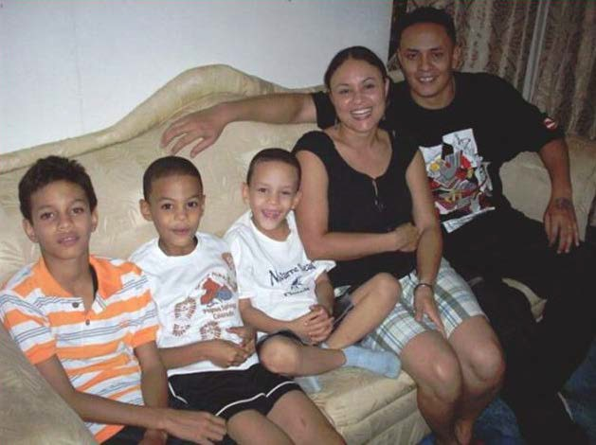
I am Fernando Arturo Ramírez Quezada. I was born on December 4, 1980 in the City of La Vega, Dominican Republic.

Shortly after my parents separated, my mother and I went to live in María Auxiliadora. I was only one year old.

Being the only child in the marriage, I had to learn to work at an early age to help
my mom. I think I used this as an excuse
to spend more time on the streets outside
the house. At the age of 12, I was already involved with drug traffickers and started selling drugs at school. Three years later I
left school to marry Rosa. By then I was the biggest and youngest drug dealer in the barrio.

Being married and having the excuse I had to help my mom, I organized a small group of thieves and drug sellers to take delinquency to a higher level in the barrio—we would do anything for money.

Five years later, the police started killing each one of my friends. We were being sought as we had caused great damage. They were tired of having us in prison and releasing us again. At the age of 20, not only had I destroyed my life, but also my wife’s and my mother’s lives.

In January 2000, a group of youth from El Camino Church (Marcos and Vicente) approached me to “spread the Word of Christ.” I thought they were daring and crazy because nobody wanted to come near me, and least of all help me.

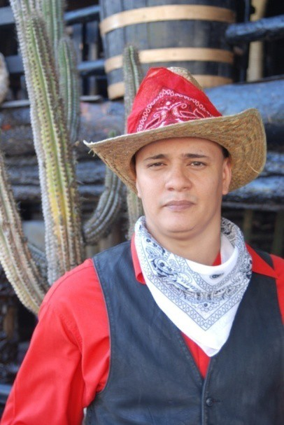
They told me how God allowed His Son to be sacrificed out of love for me. These words stayed in my head for the rest of the day. As night approached, I started to get prepared to have a good time and took all the drugs I had with me as if it was the last day of my life. All of a sudden I started crying and remembered all the words Marcos and Vicente had told me about God’s love for me. At that moment, I felt a transformation in my hard and empty heart and started to feel an eternal gratitude at being called one of His children.

Over the next 12 years, I have been growing in faith and have been able to celebrate with my wife Rosa and three children, Chris, Jeremy and Roderick, the message of salvation that Christ offered for us on the cross and the love of God for all of us.

Today I spread the Word through rap music and work as a pastor in El
Camino Church. I am also the Communications Coordinator.
El Camino Water System Staff

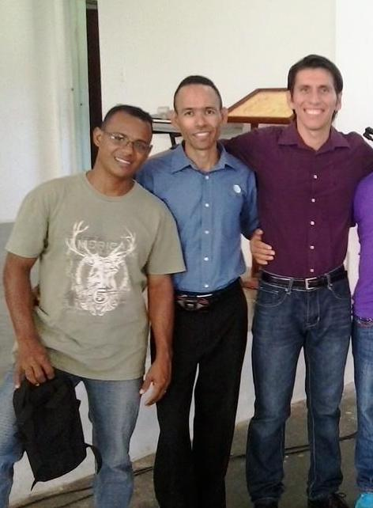

Camilo (Polo) Díaz, Máximo (Yoni) Peña Fernández, and Obed Peñuela

